Raspbian Pi SD card quick replication
version 1.00.00 from 18 July 2014

- Create SD card dump.
  - Shutdown Raspberry safely and take off SD card.
  - Insert SD card into Windows PC internal or external cardreader. Windows will give message to format card. Cancel it.
    - Some external card readers refusing to read cards with linux filesystem. You have to use another cardreader then. Internal gives best results.
  - Download and install Win32DiskImager from : http://sourceforge.net/projects/win32diskimager/
then start it.
  - In the "Image File" box, enter the path of your soon-to-be image file. For example, C:\Users\Smart\images\retrosave.img
  - Under the "Device" box, select your SD card.
  - Click the "Read" button to create the image file from your card.
  - Keep that IMG file in a safe place.
- Create SD card copy from dump.
  - Get new SD card with same or bigger size to old.
    - Remember that some manufacturers tells 4Gb space but card is actually 4GiB (4000M bytes) so make sure new card is not smaller than original. Example of bad cheap card:
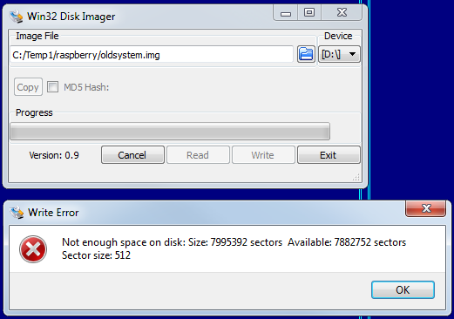
  - Insert card into card reader, make sure it was recognized by system.
  - Start Win32DiskImager installed at step 1.3.
  - Browse for the image file saved at step 1.4.
  - Select your device from the Device dropdown just as you did before.
  - Click "Write" to write the image to the SD card. Confirm operation. Depending on SD card speed (class) it will take from 5 to 15 minutes.
  - When it finishes, eject the SD card and re-insert it into your Raspberry Pi.
  - When you boot it up, it should be in the exact same state it was in when you first cloned the SD card.
- Personalize new clone.
  - Login to linux shell from console or using SSH connection (putty).
  - Start mysql command line :
mysql -u root -p0hASE
  - At the opened mysql shell enter following commands specifying new device serial and HouseID:
update hvac set value_="ASESMART-00007" where option_="system.serial";
update hvac set value_="00007" where option_="system.house_id";
quit;
  - Shutdown Raspberry using linux shell command:
sudo shutdown -h now
  - Remove SD card from RPi card slot.

That's all! You have copy of SD card for next Smart Controller now.

